**THE SUPERIOR COLLEGE LAHORE**

|  |
| --- |
| chk_captcha |

**Faculty of Computer Science & IT**

**Department of Software Engineering**

**Final Year Project**

**PROJECT REPORT (Part-1)**

**[Teacher Hiring Evaluation System]**

Project ID: **[FYP16-GROUP-022]**

**Project Team**

|  |  |  |  |  |
| --- | --- | --- | --- | --- |
| **Student Name** | **Student ID** | **Program** | **Contact Number** | **Email Address** |
| Faraz Arif | bcsm-f16-097 | BSCS | 0323-0011363 | farazarif22@gmail.com |
| Muhammad Faizan | bcsm-f16-065 | BSCS | 0313-7257412 | Chaudharyfaizan412@gmail.com |
| Muhammad Zubair | bcsm-s16-015 | BSCS | 0322-6821541 | Zubairinnocent7863@gmail.com |

**Sir Asadullah Tariq**

(Senior Lecturer)

**Project Report**

**Teacher Hiring Evaluation System**

**Change Record**

|  |  |  |  |  |
| --- | --- | --- | --- | --- |
| **Author(s)** | **Version** | **Date** | **Notes** | **Supervisor’s Signature** |
|  | 1.0 |  | <Original Draft> |  |
|  |  |  | <Changes Based on Feedback from Supervisor> |  |
|  |  |  | <Changes Based on Feedback From Faculty> |  |
|  |  |  | <Added Project Plan> |  |
|  |  |  | <Changes Based on Feedback from Supervisor> |  |
|  |  |  |  |  |
|  |  |  |  |  |
|  |  |  |  |  |
|  |  |  |  |  |
|  |  |  |  |  |

**APPROVAL**

|  |  |
| --- | --- |
| **Project Supervisor** | |
| Comments: \_\_\_\_\_\_\_\_\_\_\_\_\_\_\_\_\_\_\_\_\_\_\_\_\_\_\_\_\_\_\_\_\_\_\_\_\_\_\_\_\_\_\_\_\_\_\_\_\_\_\_\_\_\_\_\_\_\_\_\_\_\_\_\_\_\_\_ | | |
| \_\_\_\_\_\_\_\_\_\_\_\_\_\_\_\_\_\_\_\_\_\_\_\_\_\_\_\_\_\_\_\_\_\_\_\_\_\_\_\_\_\_\_\_\_\_\_\_\_\_\_\_\_\_\_\_\_\_\_\_\_\_\_\_\_\_\_\_\_\_\_\_\_\_\_\_\_ | | |
| Name:\_\_\_\_\_\_\_\_\_\_\_\_\_\_\_\_\_\_\_\_\_\_\_\_\_\_\_\_\_\_ |  | |
| Date:\_\_\_\_\_\_\_\_\_\_\_\_\_\_\_\_\_\_\_\_\_\_\_\_\_\_\_\_\_\_\_ | Signature:\_\_\_\_\_\_\_\_\_\_\_\_\_\_\_\_\_\_\_\_\_\_\_\_\_\_ | |

|  |  |
| --- | --- |
| **Project Manager** | |
| Comments: \_\_\_\_\_\_\_\_\_\_\_\_\_\_\_\_\_\_\_\_\_\_\_\_\_\_\_\_\_\_\_\_\_\_\_\_\_\_\_\_\_\_\_\_\_\_\_\_\_\_\_\_\_\_\_\_\_\_\_\_\_\_\_\_\_\_\_ | |
| \_\_\_\_\_\_\_\_\_\_\_\_\_\_\_\_\_\_\_\_\_\_\_\_\_\_\_\_\_\_\_\_\_\_\_\_\_\_\_\_\_\_\_\_\_\_\_\_\_\_\_\_\_\_\_\_\_\_\_\_\_\_\_\_\_\_\_\_\_\_\_\_\_\_\_\_\_ | |
|  |  |
| Date:\_\_\_\_\_\_\_\_\_\_\_\_\_\_\_\_\_\_\_\_\_\_\_\_\_\_\_\_\_\_\_ | Signature:\_\_\_\_\_\_\_\_\_\_\_\_\_\_\_\_\_\_\_\_\_\_\_\_\_\_ |

|  |  |
| --- | --- |
| **Head of the Department** | |
| Comments: \_\_\_\_\_\_\_\_\_\_\_\_\_\_\_\_\_\_\_\_\_\_\_\_\_\_\_\_\_\_\_\_\_\_\_\_\_\_\_\_\_\_\_\_\_\_\_\_\_\_\_\_\_\_\_\_\_\_\_\_\_\_\_\_\_\_\_ | |
| \_\_\_\_\_\_\_\_\_\_\_\_\_\_\_\_\_\_\_\_\_\_\_\_\_\_\_\_\_\_\_\_\_\_\_\_\_\_\_\_\_\_\_\_\_\_\_\_\_\_\_\_\_\_\_\_\_\_\_\_\_\_\_\_\_\_\_\_\_\_\_\_\_\_\_\_\_ | |
|  |  |
| Date:\_\_\_\_\_\_\_\_\_\_\_\_\_\_\_\_\_\_\_\_\_\_\_\_\_\_\_\_\_\_\_ | Signature:\_\_\_\_\_\_\_\_\_\_\_\_\_\_\_\_\_\_\_\_\_\_\_\_\_\_ |

# Dedication

We dedicate this project to our parents and our teachers who helped us a lot in building dedication in us for doing something to build our future. They always appreciated us for what we were doing and believed in us. We can’t even imagine making this project without the help of our teachers and family that stood firm with us and helped us a lot. We are very thankful to our teachers.

# Acknowledgements

We would like to express our special thanks to Sir Asadullah Tariq who became our supervisor and gave us an opportunity to work under him on this wonderful project on Hiring Evaluation, which also helped us in doing a lot of research and we came to know about many new things. We are really thankful to him.

Secondly, we would also like to thank our parents and friends who helped us a lot in finalizing this project within the limited time frame.

# Executive Summary

This evaluation report will be checked by the “Admin”. He/she can view the overall evaluation chart and the grades a teacher obtained. We have developed an evaluation system of the teachers to provide evaluation in an easy and quick manner to the University. So we call it as Teacher Hiring Evaluation System which delivers via the student-admin interface as online system which acts as a Service Provider. By using this online system we can make it better and quick.

# Table of Contents

[Dedication iv](#_Toc505638416)

[Acknowledgements v](#_Toc505638417)

[Executive Summary vi](#_Toc505638418)

[Table of Contents vii](#_Toc505638419)

[List of Figures ix](#_Toc505638420)

[List of Tables x](#_Toc505638421)

[Chapter 1 1](#_Toc505638422)

[Introduction 1](#_Toc505638423)

[1.1. Background 2](#_Toc505638424)

[1.2. Motivations and Challenges 2](#_Toc505638425)

[1.3. Goals and Objectives 2](#_Toc505638426)

[1.4. Literature Review/Existing Solutions 2](#_Toc505638427)

[1.5. Gap Analysis 2](#_Toc505638428)

[1.6. Proposed Solution 2](#_Toc505638429)

[1.7. Project Plan 3](#_Toc505638430)

[1.7.1. Work Breakdown Structure 3](#_Toc505638431)

[1.7.2. Roles & Responsibility Matrix 3](#_Toc505638432)

[1.7.3. Gantt Chart 3](#_Toc505638433)

[1.8. Report Outline 3](#_Toc505638434)

[Chapter 2 4](#_Toc505638435)

[Software Requirement Specifications 4](#_Toc505638436)

[2.1. Introduction 5](#_Toc505638438)

[2.1.1. Purpose 5](#_Toc505638439)

[2.1.2. Document Conventions 5](#_Toc505638440)

[2.1.3. Intended Audience and Reading Suggestions 5](#_Toc505638441)

[2.1.4. Product Scope 5](#_Toc505638442)

[2.1.5. References 6](#_Toc505638443)

[2.2. Overall Description 6](#_Toc505638444)

[2.2.1. Product Perspective 6](#_Toc505638445)

[2.2.2. Product Functions 6](#_Toc505638446)

[2.2.3. User Classes and Characteristics 6](#_Toc505638447)

[2.2.4. Operating Environment 7](#_Toc505638448)

[2.2.5. Design and Implementation Constraints 7](#_Toc505638449)

[2.2.6. User Documentation 7](#_Toc505638450)

[2.2.7. Assumptions and Dependencies 7](#_Toc505638451)

[2.3. External Interface Requirements 8](#_Toc505638452)

[2.3.1. User Interfaces 8](#_Toc505638453)

[2.3.2. Hardware Interfaces 8](#_Toc505638454)

[2.3.3. Software Interfaces 8](#_Toc505638455)

[2.3.4. Communications Interfaces 9](#_Toc505638456)

[2.4. System Features 9](#_Toc505638457)

[2.4.1. System Feature 1 9](#_Toc505638458)

[2.4.1.1. Description and Priority 9](#_Toc505638459)

[2.4.1.2. Stimulus/Response Sequences 9](#_Toc505638460)

[2.4.1.3. Functional Requirements 9](#_Toc505638461)

[2.4.2. System Feature 2 10](#_Toc505638462)

[2.4.2.1. Description and Priority 10](#_Toc505638463)

[2.4.2.2. Stimulus/Response Sequences 10](#_Toc505638464)

[2.4.2.3. Functional Requirements 10](#_Toc505638465)

[2.4.3. System Feature 3 (and so on) 11](#_Toc505638466)

[2.5. Other Nonfunctional Requirements 11](#_Toc505638467)

[2.5.1. Performance Requirements 11](#_Toc505638468)

[2.5.2. Safety Requirements 11](#_Toc505638469)

[2.5.3. Security Requirements 12](#_Toc505638470)

[2.5.4. Software Quality Attributes 12](#_Toc505638471)

[2.5.5. Business Rules 12](#_Toc505638472)

[2.6. Other Requirements 12](#_Toc505638473)

[Chapter 3 13](#_Toc505638474)

[Use Case Analysis 13](#_Toc505638475)

[3.1. Use Case Model 14](#_Toc505638476)

[3.2. Fully Dressed Use Cases 14](#_Toc505638477)

[Chapter 4 15](#_Toc505638478)

[System Design 15](#_Toc505638479)

[4.1. Architecture Diagram 16](#_Toc505638480)

[4.2. Domain Model 16](#_Toc505638481)

[4.3. Entity Relationship Diagram with data dictionary 16](#_Toc505638482)

[4.4. Class Diagram 17](#_Toc505638483)

[4.5. Sequence / Collaboration Diagram 17](#_Toc505638484)

[4.6. Operation contracts 17](#_Toc505638485)

[4.7. Activity Diagram 18](#_Toc505638486)

[4.8. State Transition Diagram 18](#_Toc505638487)

[4.9. Component Diagram 18](#_Toc505638488)

[4.10. Deployment Diagram 19](#_Toc505638489)

[4.11. Data Flow diagram [only if structured approach is used - Level 0 and 1] 19](#_Toc505638490)

[Chapter 5 20](#_Toc505638491)

[Implementation 20](#_Toc505638492)

[5.1. Important Flow Control/Pseudo codes 21](#_Toc505638493)

[5.2. Components, Libraries, Web Services and stubs 21](#_Toc505638494)

[5.3. Deployment Environment 21](#_Toc505638495)

[5.4. Tools and Techniques 22](#_Toc505638496)

[5.5. Best Practices / Coding Standards 22](#_Toc505638497)

[5.6. Version Control 22](#_Toc505638498)

[Appendices 23](#_Toc505638499)

[Appendix A: Information / Promotional Material 24](#_Toc505638500)

[Reference and Bibliography 27](#_Toc505638502)

[Index 29](#_Toc505638503)

# List of Figures

1.1 Caption of first figure of first chapter 6

1.2 Caption of second figure of first chapter 7

2.1 Caption of first figure of second chapter 14

2.2 Caption of second figure of second chapter 22

2.3 Caption of third figure of second chapter 26

5.1 Caption of first figure of fifth chapter 49

5.2 Caption of second figure of fifth chapter 49

# List of Tables

1.1 label of first table of first chapter 6

1.2 label of second table of first chapter 7

2.1 label of first table of second chapter 14

2.2 label of second table of second chapter 22

2.3 label of third table of second chapter 26

5.1 label of first table of fifth chapter 49

5.2 label of second table of fifth chapter 49

# Chapter 1

# Introduction

**Chapter 1:** Introduction

We are developing an evaluation system of the teachers to provide evaluation in an easy and quick manner to the University. So we call it as Teacher Hiring Evaluation System which delivers via the student-admin interface as online system which acts as a Service Provider. By using this technology we can make fast evaluation about the teachers by the students and inform on time to the Chairman or the heads.

This project has two types of users: Student and Admin. The student can give evaluation in online system provided by the University. First, admin can prepare questions & add or update these questions to the online system. After that it will be viewed by the students and can evaluate about the teachers.

This feedback report will be checked by the Chairman. He/she can view overall evaluation chart and view the grades obtained by the teachers and provide this report to the faculty.

## Background

In the existing system the evaluation is done by manual process which is slow and not user-friendly but in our system students can give evaluation about the teachers by using our online system without wasting their time.

In the manual system after when the feedback is given by all the students, basic reports are generated which are difficult to evaluate. Hence the performances of faculties are not estimated accurately.

So, the existing system requires detailed reports and charts for better evaluation‚ for this reason our evaluation system is implemented.

This is the major limitation of the existing system for giving evaluation about the Faculties and viewing report of the Faculties.

## Motivations and Challenges

The main problem in existing system is reports generation and charts. The existing system does not generate accurate and detailed reports which make it difficult to evaluate faculty for hiring.

Charts also play crucial role and better understandings for evaluations.

Existing system also does not include faculty or students roles in the evaluation system and so they are unable to view reports and progress through their accounts.

## Goals and Objectives

The solution will be addressed by adding detailed reports. The system will collect responses from students and evaluate the teachers and generated reports accurately along with charts.

There will be separate logins for each student and admin so they can login to submit responses and view reports.

## Literature Review/Existing Solutions

Existing system contains limited reports with no charts and user management on the system.

## Proposed Solution

The solution will be addressed by adding detailed reports. The system will collect responses from students and evaluate the teachers and generated reports accurately along with charts.

There will be separate logins for each student and admin so they can login to submit responses and view reports.

## Project Plan

The proposed system consists of two modules:

1. **Student :**

Student can give the feedback about the teachers on the scale of five. Students can give evaluation about the faculty based on interaction of faculty in the class room with students. According to that, students can give feedback as per the given grades.

1. **Admin:**

The feedback given by the students can be viewed by the staff and evaluate their performance in teaching and other aspects. These feedback reports will be checked by the Chairman’s. He can view overall evaluation charts and view the grades obtained to the teacher and give this report to the university authority and hiring of the faculty can be done.

## Work Breakdown Structure

Level 1- overall project definition

* Highest level entry corresponds to the overall project deliverables e.g. Software deliverable project.

Level 2- Identity and define deliverables

* Create user interface.

Level 3- Decompose deliverables into high-level activities

* What need to be done to complete the deliverables

Level 4- Break down activities into more granular with sub-activities.

* Break down to measurable level of detail.

## Roles & Responsibility Matrix

|  |  |  |  |  |  |
| --- | --- | --- | --- | --- | --- |
| **WBS #** | **WBS Deliverable** | **Activity #** | **Activity to Complete the Deliverable** | **Duration**  **(# of Days)** | **Responsible Team Member(s) & Role(s)** |
| 1 | Training session | 1 | Consultant professional | 1 week | All of us |
| 2 | Front End | 1 | Consult and Work with Professional Developers | 4 months | Faizan Nasir & Muhammad Zubair |
| 3 | Back End | 1 | Consult and Work with Professional Developers | 4 months | Faraz Arif & Faizan Nasir |
| 4 | Documentation | 1 | Document given the template | 1 month | All of us |
| 5 | Database Design | 1 | Finalize the database design | 1 week | Faizan Nasir |
| 6 | Database diagram | 6 | Deploy the database design | 3 day | Faizan Nasir |
| 7 | Website | 7 | Consult and Work with Professionals | 1 months | Faraz Arif & Faizan Nasir |
| 8 | Web Testing | 2 | Test cases | 1 week | All of us |
| 9 | Deployment | 5 | Deployment | 1 week | All of us |

## Gantt Chart

|  |  |  |  |  |  |  |  |  |  |  |  |  |  |  |  |  |  |  |  |  |  |
| --- | --- | --- | --- | --- | --- | --- | --- | --- | --- | --- | --- | --- | --- | --- | --- | --- | --- | --- | --- | --- | --- |
|  | Task Name | Start | Finish |  |  | | |  | | | | | | | | |  | | |  | |
| May 2020 | | | June 2020 | | | | | | | | July 2020 | | | Aug 2020 | | |
|  | Proposal Submission | 01/05/2020 | 05/05/2020 | 4d |  | | |  | | | | | | | | |  | | |  | |
|
|  | Requirement gathering | 5/05/2020 | 11/05/2020 | 6d |  |  | |  | | | | | | | | |  | | |  | |
|  |
|  | Analysis | 12/05/2020 | 17/05/2020 | 5d |  |  |  |  | | | | | | | | |  | | |  | |
|  |
|  | Designing | 18/05/2020 | 25/05/2020 | 4d |  | |  |  |  | | | |  | | | | |  | | |  |
|  |  | | | | | | | | |  | | |  | |
|  | Development | 26/05/2020 | 30/05/2020 | 7d |  | | |  | |  | | | | | | |  | | |  | |
|  | | | | | | | | |
|  | Web Testing | 31/05/2020 | 03/06/2020 | 3d |  | | |  | |  |  |  | | |  | | | | | | |
|  | | |  |
|  | Documentation | 04/06/2020 | 13/06/2020 | 10d |  | | |  | |  |  |  | |  | | | | | | | |
|  | | | | | | | | | | |

## Report Outline

In this chapter we have discussed about the background of our project and then discussed the motivations and our objectives. Than we saw the existing solution of the problem of which we are going to give solution then we discussed how can we make it successful at last we see the three major diagrams **WBS, Roles & Responsibility Matrix, Gantt Chart,** Which make a lot of things clear about the project.

# Chapter 2

# Software Requirement Specifications

**Chapter 2:** Software Requirement Specifications



## Introduction

This evaluation report will be checked by the “Admin”. He/she can view the overall evaluation chart and the grades a teacher obtained. We have developed an evaluation system of the teachers to provide evaluation in an easy and quick manner to the University. So we call it as Teacher Hiring Evaluation System which delivers via the student-admin interface as online system which acts as a Service Provider. By using this online system we can make it better and quick.

## Purpose

Purpose is to facilitate administration to evaluate faculty that university need to hire.It will save the time of all the management in evaluation. Teacher Hiring Evaluation System is allowing management to review the performance of faculty through website and easily evaluate without wasting time. If the system can do evaluation work effective then why waste time in rotten old systems. In this THES we covered all over the documentation each and everything related to this project. All functional & non-functional requirements, system diagrams each and everything Document.

## Document Conventions

Main section titles

* Font: Calibri body
* Face: bold
* Size: 16

Sub selection titles

* Font: Calibri body
* Face: bold
* Size: 14

Other text explanations

* Font: Calibri body
* Face: normal
* Size: 12

## Intended Audience and Reading Suggestions

Describe the different types of reader that the document is intended for, such as developers, designers, project managers, management, students, testers, and documentation writers. Describe what the rest of this THES contains and how it is organized. Suggest a sequence for reading the document, beginning with the overview sections and proceeding through the sections that are most pertinent to each reader type.

## Product Scope

Through our system we hope to accomplish following major goals:

Management benefits:

* Time saving
* Quality assurance
* Evaluation with Charts
* Grading System
* User Friendly

Student benefits:

* Better Faculty through Evaluation
* Quality Education

Service provider’s benefits:

* Business startup
* Research based learning activity

**DIAGRAM:**

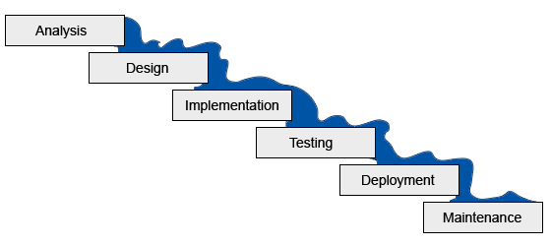

## Overall Description

## Product Perspective

This system is a follow up on the current system in which there is too difficult to accurately evaluate the faculty as it consumes a lot of time to review. It is planned to replace the existing system. That will save both time and easy to evaluate through charts and grading anywhere just by accessing the website.

## Product Functions

**WebApp: Teacher Hiring Evaluation System**

* **Student/Admin Signup:** Student/Admin can Signup.
* **Student Login:** Student can login.
* **Admin Login:** Admin can login.
* **Logout:** Student/admin can also logout.
* **Forgot Password:** User can recover his/her password.
* **View Report:** Admin can view report.
* **Submit Evaluation:** Student can login and submit the evaluation for faculty member.
* **Create Feedback Form:** Admin can create feedback and assign to a batch for evaluation.

## User Classes and Characteristics

There would be 2 types of users which will have access to the evaluation system admin and students. Both types of users will have different roles or accesses. Admin can create feedback and assign to a batch and students of that batch will be able to submit the feedback which then admin can review or evaluate.

## Operating Environment

It will be a web based application which will be accessible through chrome, firefox, safari opera. There is no limitation to the OS used as this is a website.

## Design and Implementation Constraints

There is no major constraint for this project’s implementation. This is a web based project which will be hosted on an active host and the users will require active internet connection for submission of feedback.

* + - * This system is working for single server.
      * Limited to HTTP/HTTPS.
      * Tools that are used for development and deployment of the system:
        + XAMPP server for the local host
        + MYSQL used for manage the database specification

## User Documentation

A separate user manual for each user role should be delivered with this application which will document how the system should be maintained.

Additionally, a tutorial shall be provided for the user describing the major use cases for each role.

User can send the E-mail to the professionals for further help.

User must know detail of our product, how to use it or how to deploy it.

User must use internet to access our product.

## Assumptions and Dependencies

It is assumed that the students in universities would like to evaluate their faculty and they would be familiar with the application as it requires simple login/signup and feedback submission in user-friendly way and students are familiar with the internet usage. The whole application is internet based so there is a need of internet every time and universities offer free wifi.

## External Interface Requirements

According to Richard Thayer (2002), "External interface requirements specify hardware, software, or database elements with which a system or component must interface...." This section provides information to ensure that the system will communicate properly with external components.

## User Interfaces

The login interface will be similar to this one.

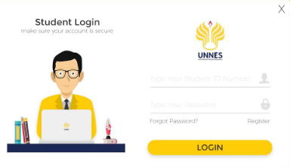

## 

## Hardware Interfaces

This is a simple web based application so there is no need of any specific hardware requirement. Just internet connection and any common browser will be enough to access the system.

## Software Interfaces

* + Notepad++
  + XAMPP

## Communications Interfaces

The communication on this system will be done by using web browser as it is a web based application and it will require active internet connect. The communication will be done through http.

## System Features

## System Feature 1

Logins of admin is provided so that the data is managed easily and provide them a better control.

## System Feature 2

Signup of Students are provided so that the data is managed easily and provide them a better service.

## System Feature 3

The application must allow users to recover password using Password Forgot Feature.

## System Feature 4

The application must allow admin to create feedback and assign to batches and faculty.

## System Feature 5

The application must allow students to submit feedback for faculty assigned by admin under their batch.

## System Feature 6

The application must allow admin to review the grading and charts of submitted responses from the students.

## Other Nonfunctional Requirements

## Performance Requirements

The only requirement for this application is web browser where user can login or signup using internet connection.

## Safety Requirements

The developers ensure the application works smoothly without bugs and for that we have provided an email where users can contact in case of any bug or issue to get is resolved quickly.

## Security Requirements

Only students and administration has access to this application and no general user can get signed up to this system. The evaluation can be done by students so only students will be able to access the application for feedback submission.

## Software Quality Attributes

**Reliability**

The Teacher Hiring Evaluation system can be utilized by students and administration simultaneously.

**Availability**

The application is accessible amid 24 hours of the day.

**Maintainability**

The application should give the ability to go down the Data.

**Portability**

Users can sign in to the application whenever.

**Robustness**

The application won't be separated effortlessly.

# Chapter 3

# Use Case Analysis

**Chapter 3:** System Analysis

In this Chapter we provide the whole System model that how to use the system and what work has been done by which actor. And tells us the success scenarios what is the main goal of our system or system functions and tells the actor responsibilities

## Use Case Model

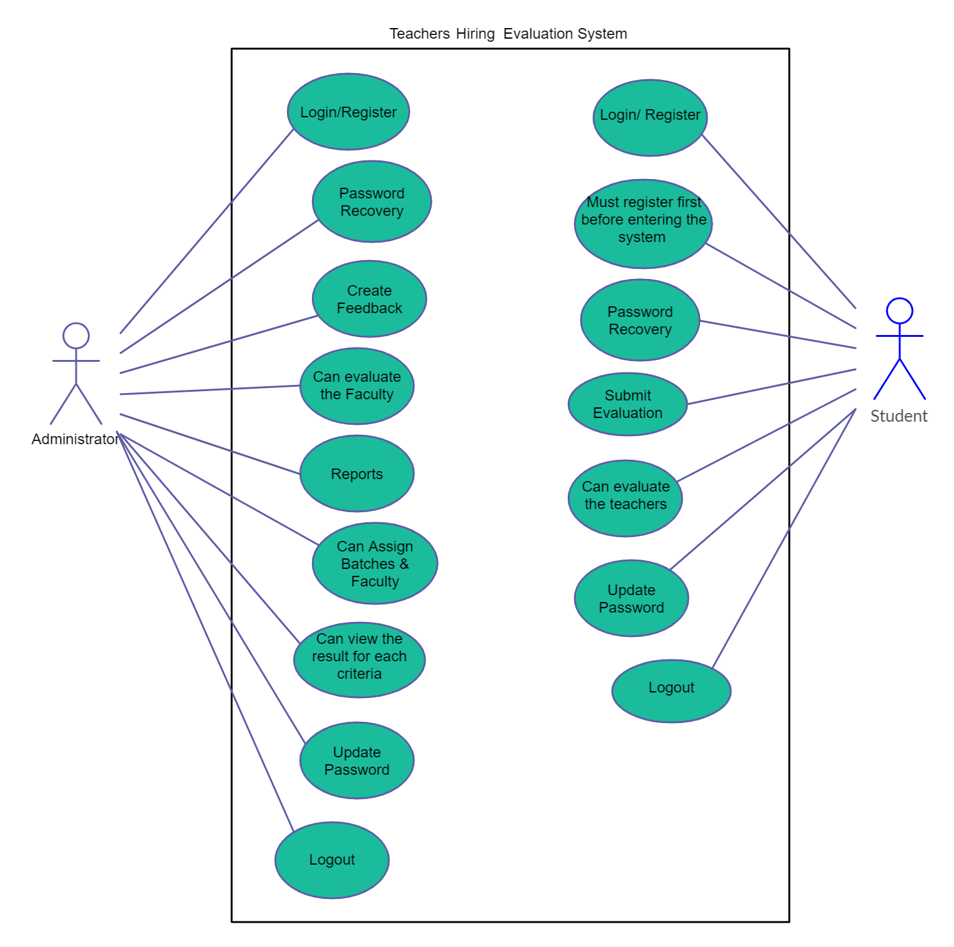

## Fully Dressed Use Cases

1. **Use case name:**

Login

**Scope:**

The Scope of login is only Authorized person can access and through this id only.

**Primary Actor:**

Admin and Student can login

**Main Scenario:**

* Firstly, the User has to login.
* If they are not registered then they must register before login.
* After login the User get access depending on actor.

**Failure Scenario:**

* The actor has failed to login by providing wrong input
* Failure may occur through server problem
* Show the Error if the User cannot provide correct input.
* If the there is no server problem or it is already register then it should be contact with the administrator.

1. **Use case name:**

Registration

**Scope:**

The Scope of registration is only Authorized person can access and through this id only.

**Primary Actor:**

Admin and Student can register

**Pre-Conditions:**

The user should have valid information to online register by providing his/her correct information and these criteria apply on all actors.

**Main Scenario:**

* Firstly, the User has to login.
* If they are not registered then they must register before login.
* After login the User get access depending on actor.
* After successful registration the Actor providing a unique id.

**Failure Scenario:**

* The actor has failed to register by providing wrong input
* Failure may occur through server problem
* Admin can reject the registration request
* If the there is no server problem or it is already register then it should be contact with the administrator.

1. **Use Case Name:**

Feedback

**Scope:**

The Scope of feedback is to allow admin to create feedback and assign that to batches.

**Primary Actor:**

Admin

**Pre-Conditions:**

The admin should have to login first and can able to use this feature.

**Main Scenario:**

* Firstly, the Admin has to login.
* If they don’t register then it must be register before login.
* After login the admin get our services.

**Failure Scenario:**

* The actor has failed to login by providing wrong input
* Failure may occur through server problem
* Show the Error if the User cannot provide correct input.

1. **Use Case Name:**

Reports

**Scope:**

The Scope of Reports is to allow admin the access of reports of feedbacks submitted by the students.

**Primary Actor:**

Admin

**Pre-Conditions:**

The admin should have a must be login for viewing report.

**Main Scenario:**

* Firstly, the User Admin has to login
* Click the reports button
* Now can review reports of feedbacks submitted by students

1. **Use Case Name:**

Submit Evaluation

**Scope:**

The Scope of submit evaluation is to allow the student to submit feedback on faculty.

**Primary Actor:**

Student

**Pre-Conditions:**

The user should have to login first and can give feedback by using this feature.

**Main Scenario:**

* Firstly, the User has to login.
* If they don’t register then it must be register before login.
* After login the User get this feature access.
* After successful registration the User can give feedback.